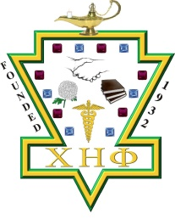
Gladys Catchings
Award

In celebration of our Founder, a member of Alpha Eta Chapter Inc. will be selected to receive the Soror Gladys Catching Award.
Instructions:
- Review the criteria for the award found in the policy “Gladys Catchings Award.”
- Using this form* write a recommendation explaining how your nominee meets the criteria and should be selected for the award.
- Submit the recommendation to the Chair of this Award Committee within sixty (60) of Founders Day or determined by the Basileus in collaboration of the committee.

Nominator’s Name:
Date of Submission:

